Nội dung kiểm tra CK II - NH 2024 – 2025
Anh 9 ilsw (Unit 5 --> Unit 8)
Choose the word whose underlined part is pronounced differently from that of the others (0.5pt)
- ed
- vowel
Choose the word whose main stress pattern is not the same as that of the others (0.5pt)
- 1^{st/} 2nd syllable
- 3rd syllable
Multiple Choice: Choose the best answer (A, B, C or D) (3pts)
- 2 pictures – 1 verb form (It’s time/ S + would rather….) – 1 Preposition - 1 conversation – Conjunction
- 6 vocabulary ---→ 16
Choose the word phrase (A, B, C or D) that best fits the space in the following text. (1.5 pts)
Câu 17 → Câu 22
Các bài đọc liên quan đến chủ đề từ Unit 5 → Unit 8
Read the following passage. Decide if the statements from 23 to 26 are True or False and choose the correct answer (A, B, C or D) for the questions 27 and 28. (1.5 pts)
Câu 23 → Câu 28
Các bài đọc liên quan đến chủ đề từ Unit Unit 5 → Unit 8
Use the correct form of the word given in each sentence. (1.5 pts)

29 - 34
No | Verbs | Nouns | Adjectives | Adverbs | Meanings
1 1 | attract | attraction | attractive | attractively | Thu hút
22 2 |  | congestion | congested |  | Tắc nghẽn
333 3 | direct | direction/ director |  | directly | Điều hướng
4 4 4 | encourage | encouragement | encouraging |  | Động viên
5 5 |  | home | homeless/ homesick |  | nhà
6 | innovate | innovation |  |  | Đổi mới
7 7 |  | manual | manual | manually | Thủ công, bằng tay
8 8 | own | owner |  |  | Sở hữu
9 9 | personalize | person/ personalization | personalized |  | Cá nhân hóa
10 |  | profession | professional | professionally | Chuyên nghiệp
11 | produce | production/ product/ producer |  |  | Sản xuất
12 |  | psychology/ psychologist |  |  | Tâm lí học
13 |  | reality | real | really | Thực sự/ tế
14 | solve | solution |  |  | Giải pháp

Dictionary Entry
35-36
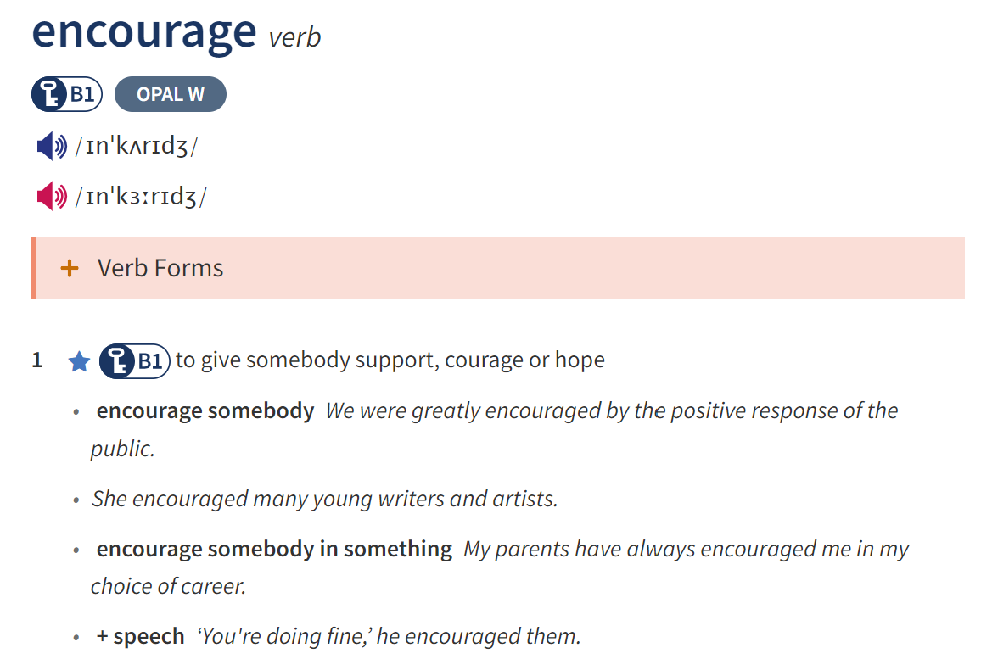
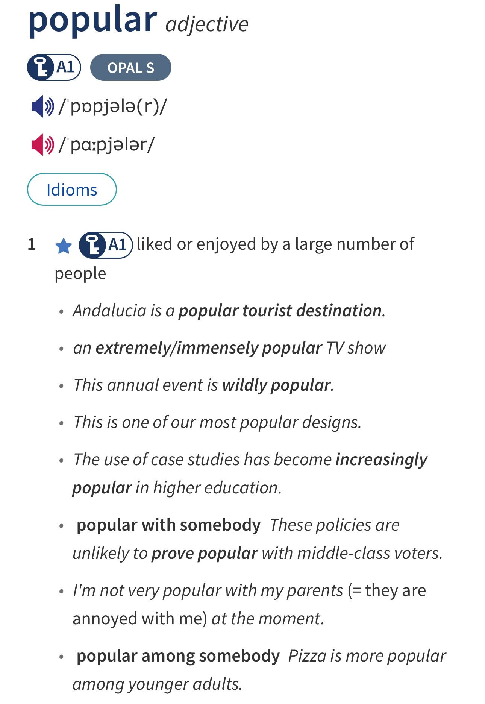
Sentence Transformation (1pt)
37. so <-> such
38. If Clause – Type 1 (and/ or)
39. During → While/ When
40. should + V → advise + obj. + to V
Having …, you can… → allow + O + to V
Spend<-> it takes/ took + to V

